CAREER OBJECTIVE:
Looking for an opportunity to utilize my strengths to build my career that would intrinsically help me in achieving greater practically excellence in technical domain, exceptional hardworking nature along with good communication skills to explore the requirements and come up with innovative solutions.
EDUCATIONS:
2013- Bachelor of Electronic Communication Engineering from Mara Technology University (CGPA: 3.00)
2010-Diploma Of Electric Electronic From Mara Technology University (CGPA: 2.79)
SUMMARY QUALIFICATIONS:
Handling multifaceted technical assistant tasks planning, filing, records management and safety work as the assistant to engineer. Coordinated travel arrangements, maintained database and ensured the system will be smooth. Quickly became a trusted assistant known for“can-do”attitude, flexibility and high-quality work. Highlights:
- Communicated effectively with multiple departments to doing the planning, dealing with customers and recording. Established strong relationships to gain support and effectively Achieved results.

- Entrusted to manage office with the supervisor’s. Provided timely, courteous and knowledgeable response to information requests; screened and transferred information; and Prepared official works.

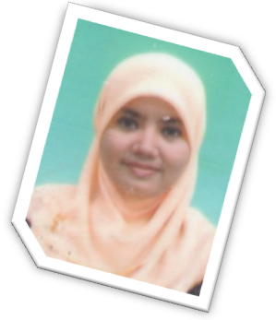
- Earned excellent marks on performance reviews, with citations for excellence in areas including work volume, accuracy and quality; ability to learn and master new concepts: positive work ethic and commitment

KEY SKILLS:
- WRITTING AND SPEAKING
MALAY - FLUENT
ENGLISH - AVERAGE

- COMPUTER SKILLS


EXPERIENCE:
- TECHNICAL ASSISTANT (PLANNER)
Acess Network Development (AND)
Telekom Malaysia Berhad,74540
Ayer Keroh Melaka

PROJECTS HANDLED:
- Business As Usual
( COPPER)
- Non Planning Project
(USER EDGE PROVIDER)
- High Speed Broadband
(UNIFI)

REFFERENCES:
Mohd Pikri B Loman
Head Deapartment
Access Network Development
TM Melaka.
019-3330864

Zulkaple b Rabu
Supervisor
Access Network Development
TM Melaka
019-6183373
NOR SYAZWANI ISMAIL

NO 11 TMN INDAH TITI GAJAH
06550 ALOR SETAR KEDAH


alannaqish3077@gmail.com
019-3621060

